GREENHILL ACADEMY
NURSERY ACTIVITY - TERM ONE 2018
WK. 7
NAME: ______________________________________ STREAM:______________
DATE: __________________________________

Colour the sheep.

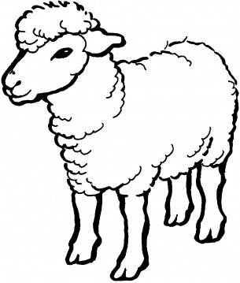

GREENHILL ACADEMY
NURSERY ACTIVITY - TERM ONE 2018
WK. 7
NAME: ______________________________________ STREAM:______________
DATE: __________________________________

Match the sound to its picture.
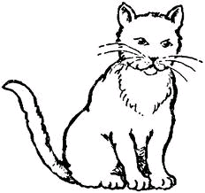
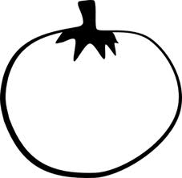
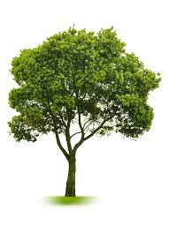
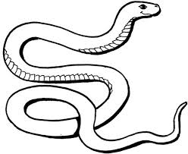

s
p
n
a
h
c
t
!

GREENHILL ACADEMY
NURSERY ACTIVITY - TERM ONE 2018
WK. 7
NAME: ______________________________________ STREAM:______________
DATE: __________________________________

Match the same shapes and colour.

GREENHILL ACADEMY
NURSERY ACTIVITY - TERM ONE 2018
WK. 7
NAME: ______________________________________ STREAM:______________
DATE: __________________________________

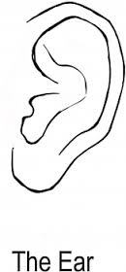
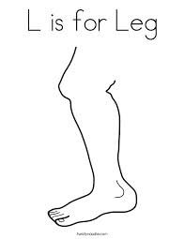
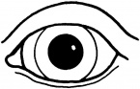

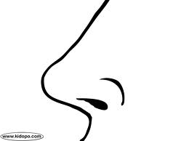
Match the same body parts.

GREENHILL ACADEMY
NURSERY ACTIVITY - TERM ONE 2018
WK. 7
NAME: ______________________________________ STREAM:______________
DATE: _______________________________________

count and write
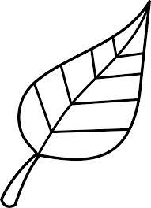
=

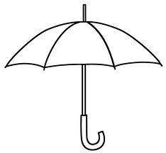
=


=
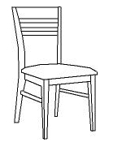
=

=

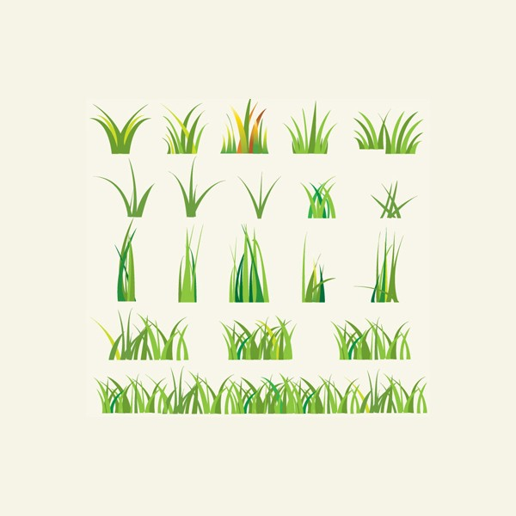
=

Manyangwa modern primary school
NURSERY ACTIVITY - TERM ONE 2018
WK. 8
NAME: ______________________________________ STREAM:______________
DATE: __________________________________

Count and match.

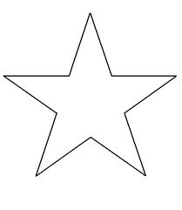

GREENHILL ACADEMY
NURSERY ACTIVITY - TERM ONE 2018
WK. 8
NAME: ______________________________________ STREAM:______________
DATE: __________________________________

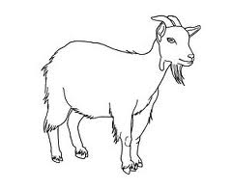
Read and colour well.
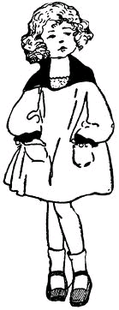






GREENHILL ACADEMY
NURSERY ACTIVITY - TERM ONE 2018
WK. 8
NAME: ______________________________________ STREAM:______________
DATE: __________________________________

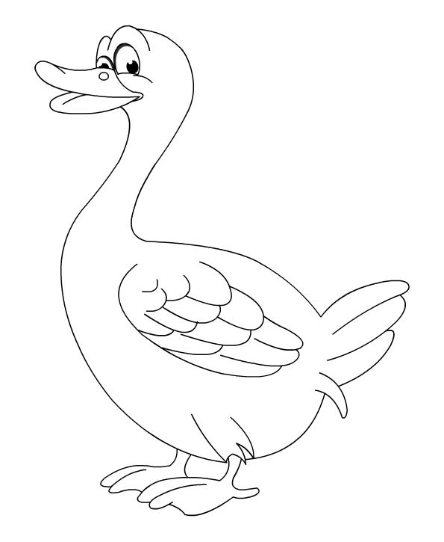
Read and colour well.
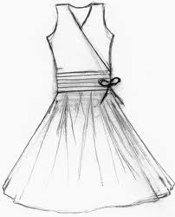



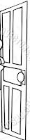

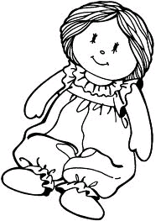

GREENHILL ACADEMY
NURSERY ACTIVITY - TERM ONE 2018
WK. 8
NAME: ______________________________________ STREAM:______________
DATE: __________________________________

Colour the hen and its chicks.

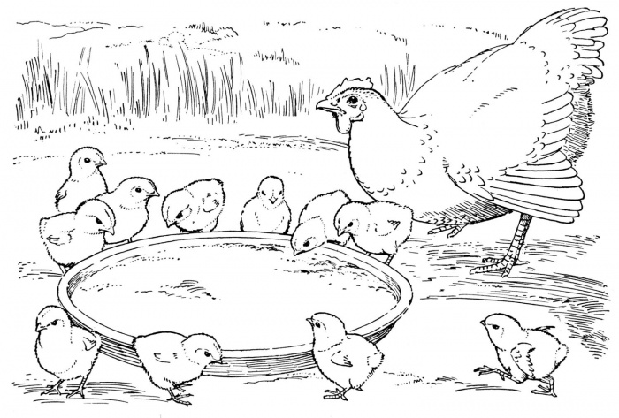

GREENHILL ACADEMY
NURSERY ACTIVITY - TERM ONE 2018
WK. 8
NAME: ______________________________________ STREAM:______________
DATE: __________________________________

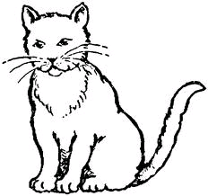
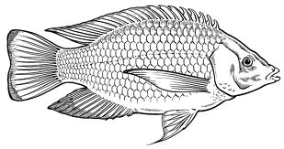
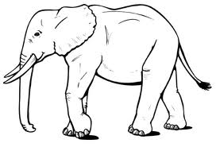
Colour only animals found at home.

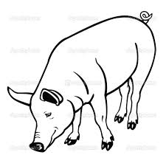
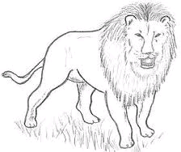

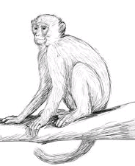
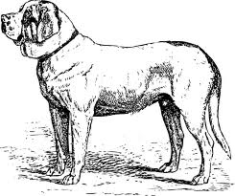
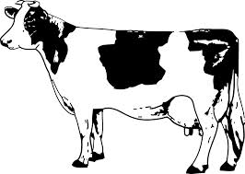

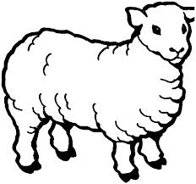
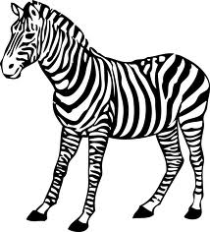

GREENHILL ACADEMY
NURSERY ACTIVITY - TERM ONE 2018
WK. 9
NAME: ______________________________________ STREAM:______________
DATE: __________________________________

Match pictures to sounds correctly.

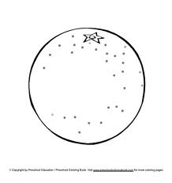
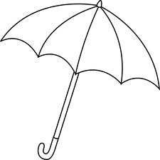
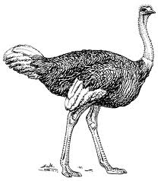
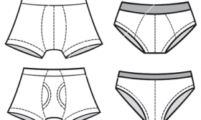
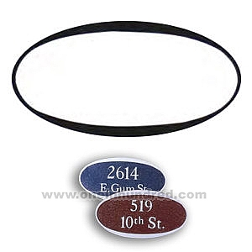
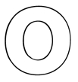
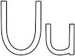

GREENHILL ACADEMY
NURSERY ACTIVITY - TERM ONE 2018
WK. 9
NAME: ______________________________________ STREAM:______________
DATE: __________________________________

Colour the elephant nicely.
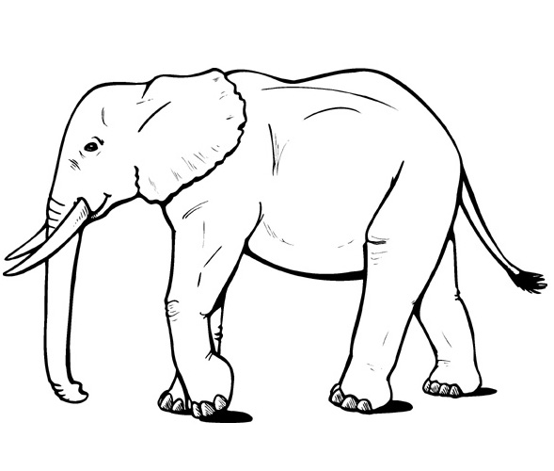

GREENHILL ACADEMY
NURSERY ACTIVITY - TERM ONE 2018
WK. 9
NAME: ______________________________________ STREAM:______________
DATE: __________________________________

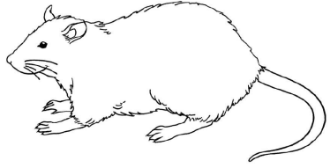
Colour and match the same pictures of wild animals.

GREENHILL ACADEMY
NURSERY ACTIVITY - TERM ONE 2018
WK. 9
NAME: ______________________________________ STREAM:______________
DATE: __________________________________

Write numbers 1 up to 5.

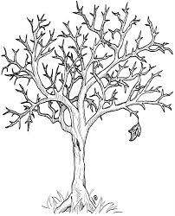
Count and write.

= =

=

= =

GREENHILL ACADEMY
NURSERY ACTIVITY - TERM ONE 2018
WK. 9
NAME: ______________________________________ STREAM:______________
DATE: __________________________________

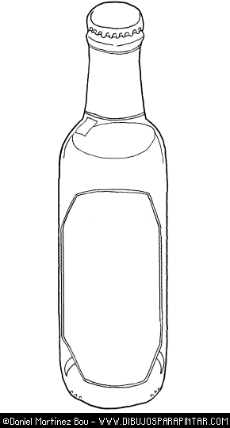
Colour the picture for the given sound.
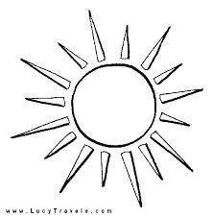

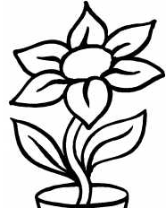
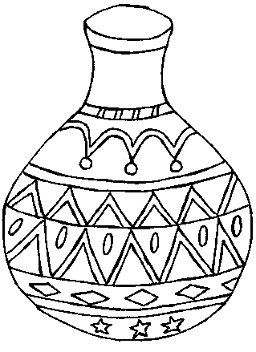

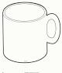
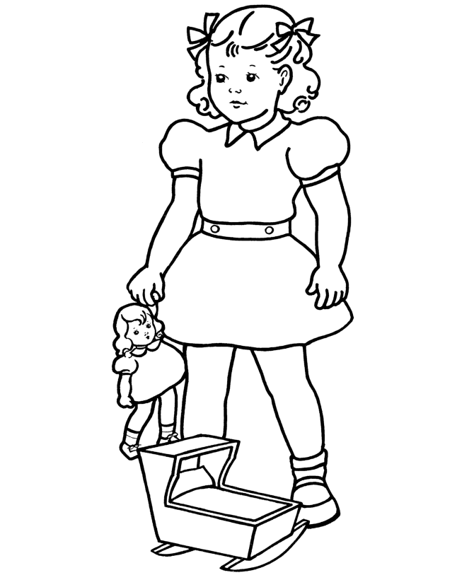

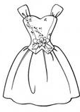
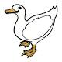

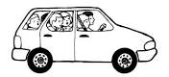

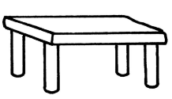
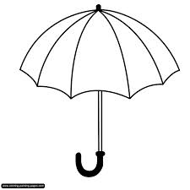

GREENHILL ACADEMY
NURSERY ACTIVITY - TERM ONE 2018
WK. 10
NAME: ______________________________________ STREAM:______________
DATE: __________________________________

Read and colour well.
Sound letter “l” and its pictures.
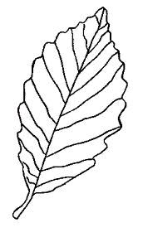

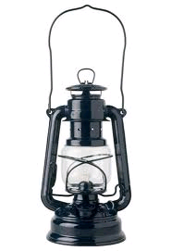

GREENHILL ACADEMY
NURSERY ACTIVITY - TERM ONE 2018
WK. 10
NAME: ______________________________________ STREAM:______________
DATE: __________________________________

Read and colour well.
Sound letter “f” and its pictures.

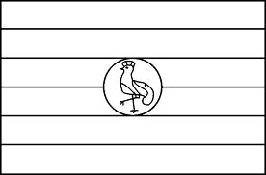

GREENHILL ACADEMY
NURSERY ACTIVITY - TERM ONE 2018
WK. 10
NAME: ______________________________________ STREAM:______________
DATE: __________________________________

Count and colour well.



GREENHILL ACADEMY
NURSERY ACTIVITY - TERM ONE 2018
WK. 10
NAME: ______________________________________ STREAM:______________
DATE: __________________________________

Write a sound for the given picture.

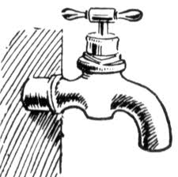

GREENHILL ACADEMY
NURSERY ACTIVITY - TERM ONE 2018
WK. 10
NAME: ______________________________________ STREAM:______________
DATE: __________________________________

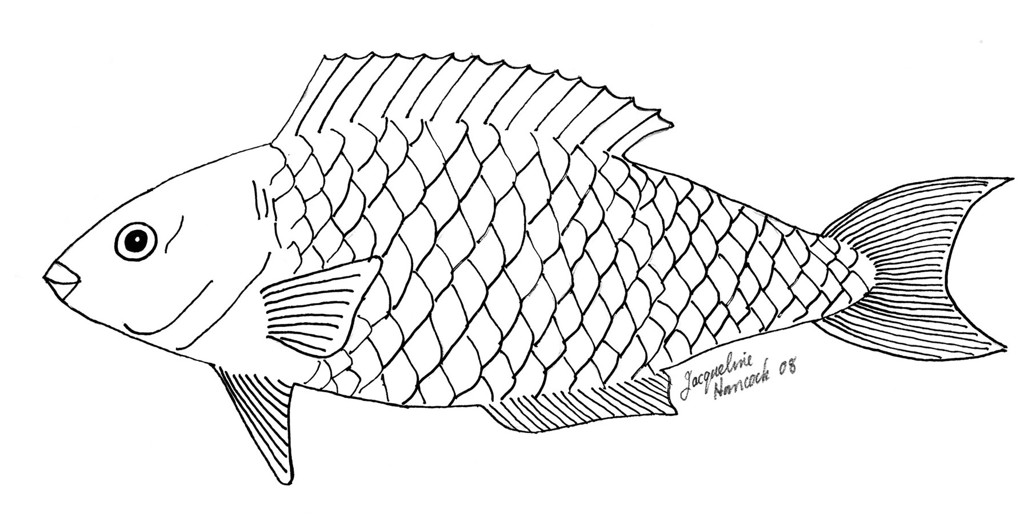
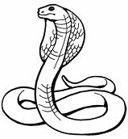
Colour the water animals.

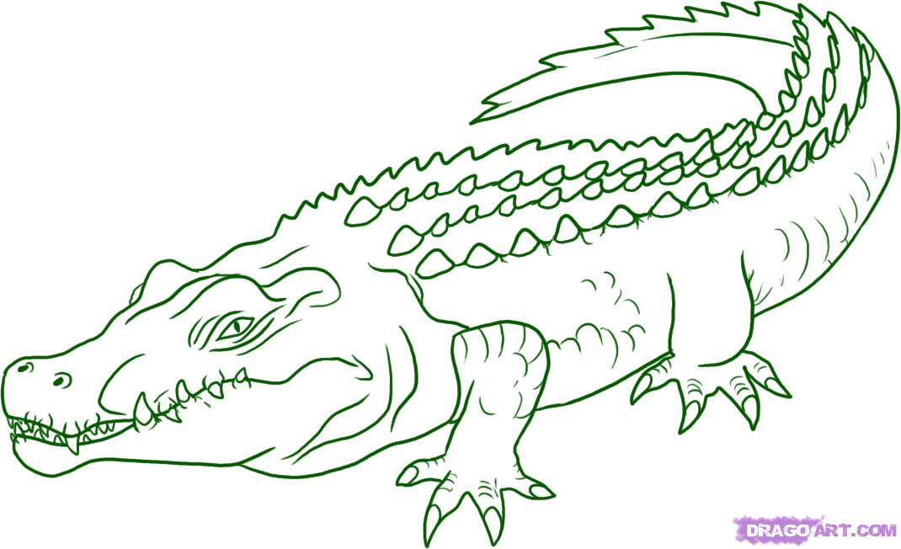
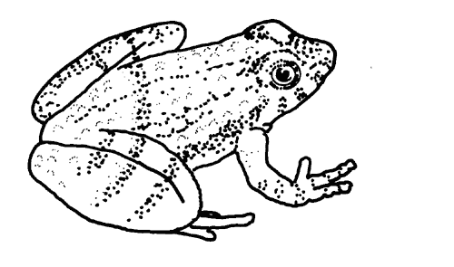

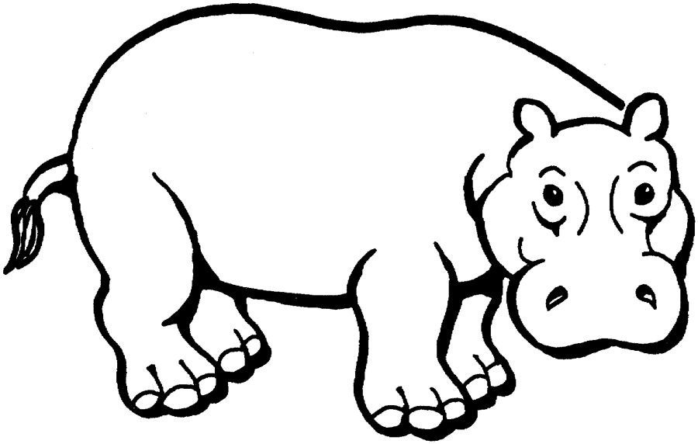
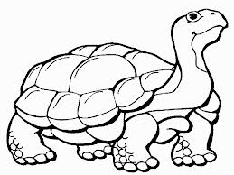

GREENHILL ACADEMY
NURSERY ACTIVITY - TERM ONE 2018
WK. 10
NAME: ______________________________________ STREAM:______________
DATE: __________________________________

Colour the shapes.
Circle - red, triangle - yellow, square - blue and rectangle - green.

GREENHILL ACADEMY
NURSERY ACTIVITY - TERM ONE 2018
WK. 10
NAME: ______________________________________ STREAM:______________
DATE: __________________________________

Write numbers 1 up to 6

Count and circle.
4 5 3


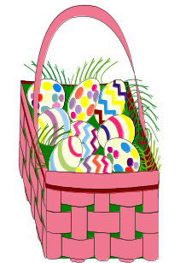
5 1 2

3 4 1


1 4 3

5 3 2

